Practical No.1
Aim:Creation of Test Suite Using Selenium IDE
Tool: Selenium IDE (Chrome/Firefox Extension) Install Selenium IDE and create a test suite containing a minimum of four test cases to validate different web page formats (HTML page, XML response, JSON API output, and a dynamic form page). Execute the suite and export the automation script in WebDriver format.
REQUIREMENTS:
1) Selenium IDE extension on a browser.
2) NetBeans IDE for creating test case files.
STEPS:
1. Open Google and search for “Selenium IDE Chrome.”
2. Select the first search result and navigate to the Selenium IDE extension page. 3. Click “Add to Chrome” to install the extension in your browser.
4. For testing, we need a test case suite, so we create a WebApplication in NetBeans IDE. File > New Project > Java Web > Web Application > Add GlassFish Server > Finish. 5. In index.html, we write the following code for “ARITHMETIC OPERATIONS” test case suite:
---index.html---
<html>
<head>
<title>prac1</title>
<script language="javascript">
function addition()
{
var num1=parseInt(document.arithmetic.n1.value);
var num2=parseInt(document.arithmetic.n2.value);
var result=num1+num2;
document.arithmetic.res.value=result;
}
function subtraction()
{
var num1=parseInt(document.arithmetic.n1.value);
var num2=parseInt(document.arithmetic.n2.value);
var result=num1-num2;
document.arithmetic.res.value=result;
}
function multiplication()
{
var num1=parseInt(document.arithmetic.n1.value);
var num2=parseInt(document.arithmetic.n2.value);
var result=num1*num2;
document.arithmetic.res.value=result;
}
function division()
{
var num1=parseInt(document.arithmetic.n1.value);
var num2=parseInt(document.arithmetic.n2.value);
var result=num1/num2;
document.arithmetic.res.value=result;
}
</script>
</head>
<body>
<h1 align="center"> Arithmetic Operations </h1>
<form name="arithmetic">
<table border="1" align="center">
<tr>
<td>Number 1: </td>
<td><input type="text" name="n1" size="20"></td>
</tr>
<tr>
<td>Number 2: </td>
<td><input type="text" name="n2" size="20"></td>
</tr>
<tr>
<td colspan=2>
<input type="button" name="add" value="Add"
onclick="javascript:addition();">&nbsp;
<input type="button" name="sub" value="Subtract"
onclick="javascript:subtraction();">&nbsp;
<input type="button" name="mul" value="Multiply"
onclick="javascript:multiplication();">&nbsp;
<input type="button" name="div"
value="Divide" onclick="javascript:division();">&nbsp;
</td>
</tr>
<tr>
<td colspan="2">Result is: <input type="text" name="res" size="20" value=""></td>
</tr>
</table>
</form>
</body>
</html>
1) Create a JSP file “newjsp.jsp” with a link to the created HTML file.
---newjsp.jsp---
<%@page contentType="text/html" pageEncoding="UTF-8"%>
<!DOCTYPE html>
<html>
<head>
<meta http-equiv="Content-Type" content="text/html; charset=UTF-8"> <title>JSP Page</title>
</head>
<body align="center">
<h1>Test Cases IDE</h1>
<a href="index.html">Arithmetic Operations</a>
</body>
</html>
2) Run this JSP file from NetBeans. It will then open up in a browser.
• Then from the browser, open the link:
• Now you’ll be redirected to ARITHMETIC OPERATIONS page.
Copy the URL of the page and open “Selenium IDE” extension:
• Now, Record a new test project in a new project:
• Name your project:
• Paste that URL here and click Start Recording:
• A new tab will be opened, maximize that tab(this tab is your working tab for recording):
Click on Stop Recording:
• Just as you stop your recording, you’ll be prompted to Name your new test, we’ll make our new test as “addition”:
• Save the project after each test case:
• A file with “.SIDE” extension will be saved(SIDE abbrev to Selenium IDE): • Now, we’ll Start Recording our first test case(addition):
• We’ll be prompted to paste our URL again, then click Start Recording • NOTE THAT each clicks are recorded:
• Now we’ll Stop Recording from the Selenium IDE:
• We’ll then Run current
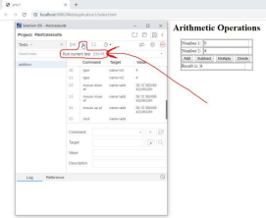
• test(addition):
• The test will run automatically and the completion will be shown step-by-step in the “Log” area in the Selenium IDE:
• NOTE1: You can set the “Test execution speed” too:
NOTE2: Paste here the URL again if the Glassfish Error occurs between any test case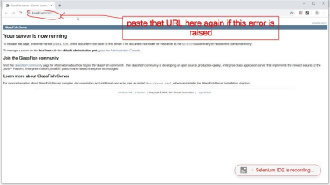
• Now create 3 more test cases(subtraction, multiplication, division). Then “Run all tests”: 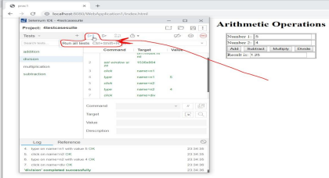1) Finish!

